جامعة بوليتكنك فلسطين | 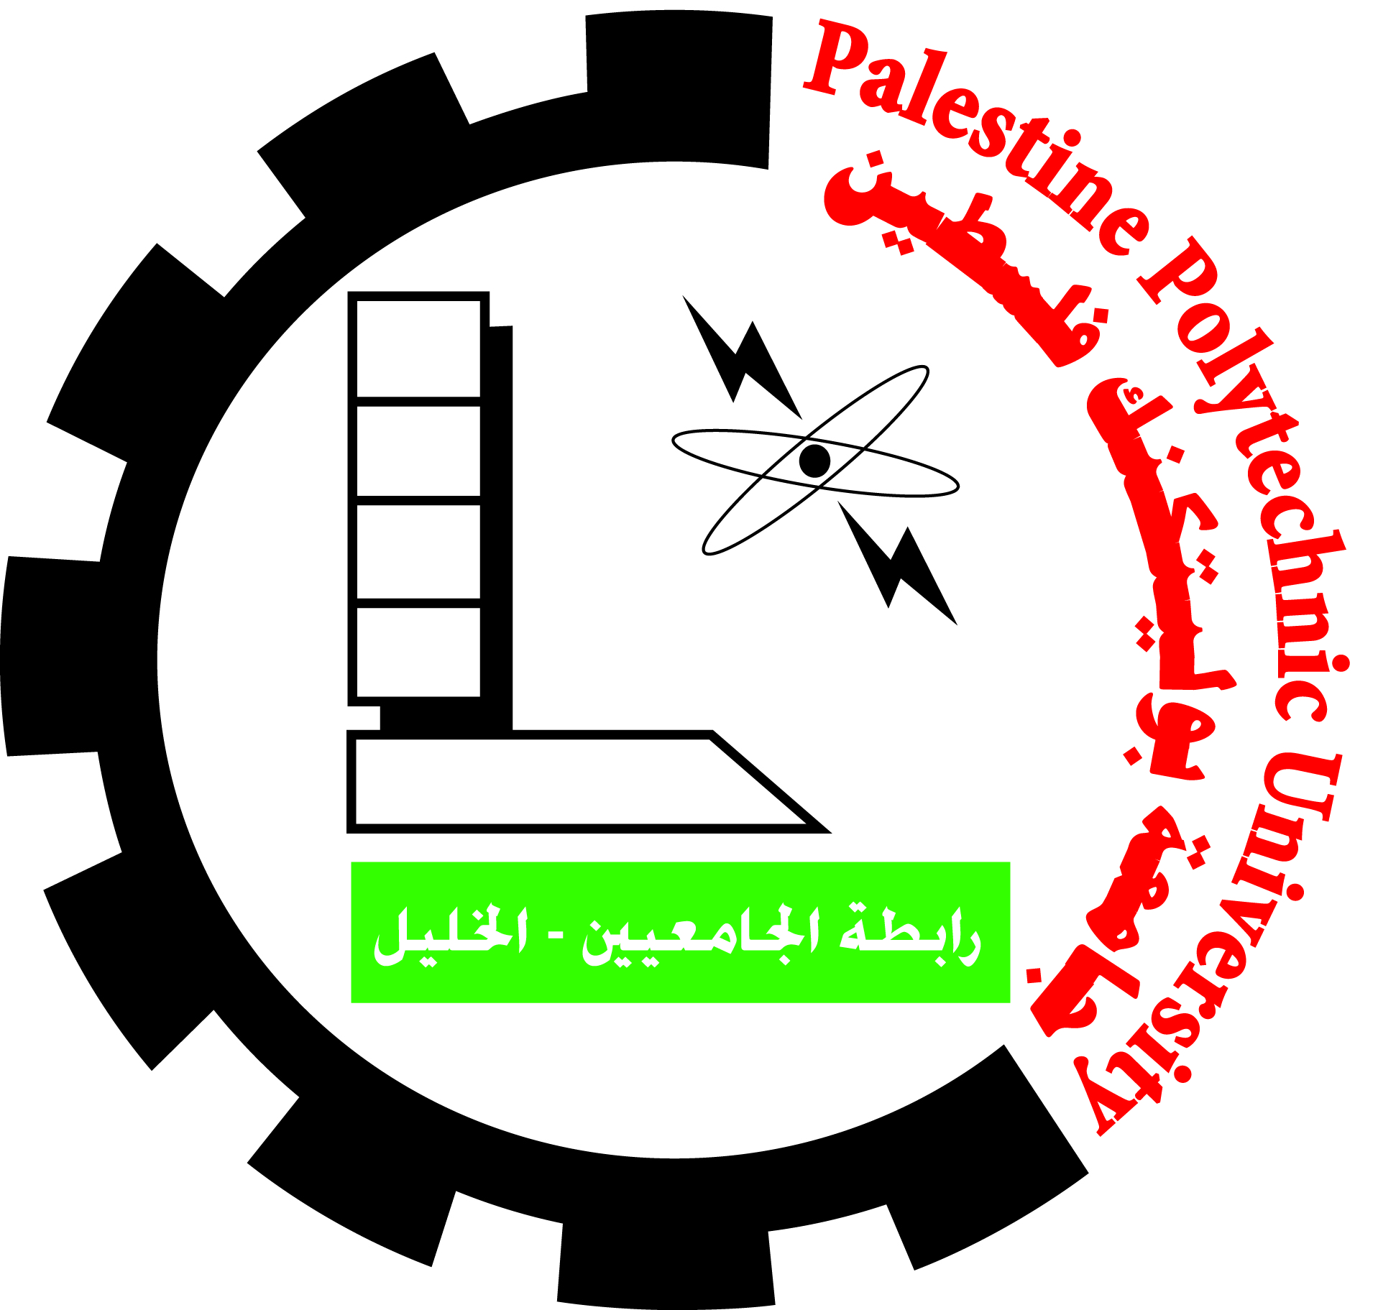 | Palestine Polytechnic University
عمادة الدراسات العليا والبحث العلمي |  | Deanship of Graduate Studies and Scientific Research

جائزة البنك الإسلامي الفلسطيني للبحث العلمي: نموذج تقييم المشاركات

الفئة الخامسة: جائزة المجموعات البحثية على مستوى جامعة بوليتكنك فلسطين
- Summary:

Published Results | Research Field | Establishment Date | Researcher/s | Research Group Title

- Scoring sheets

Score | More than | Three Researchers | Two Researchers | Single Researcher | Number of researcher working in the group
 | 15 | 13 | 10 | 0 | Number of researcher working in the group

A | Number of funded project (inter+external)  N6= | Others (workshops, conferences, presentations)  N5= | Number of attended  Conferences with presented papers  N4= | Number of achieved awards & prizes  N3= | Number of generated patents  N2= | Number of generated high quality papers  (Scopus, ISI or higher)  N1= | Research groups’ Activities & Achievements (pts)
 | N6*8 | N5* 3 | N4*5 | N3* 6 | N2* 15 | N1* 10 | Scoring Tools

B | There is no use… | Indirectly… | Directly… | The research group services toward community needs (pts)  ( with max 20 pts)

Grand Total = A + B | Total Score for Research Group/ Code:………….

Committee Approval: ……………………………./ :………………………………….. / :……………………………………
Date:……………………

